|  |
| --- |
| **Church News**  radiYAte Weekend Away  Young adults weekend away is happening Sept 14-16! Our speaker is James Chen. Registrations still open!  FRESH in August  We'll be running 5 weeks of supper and dialogue for our non-Christian friends starting August 8 in Kingsgrove. Think about whether you'd like to come and who you can invite.  Reachout Missions Conference (Sept 8-9 in Katoomba)  God calls all to partake in His great mission, whether you are looking to go short term/long term or still trying to figure out. ReachOut conference is a good way to learn more about missions and different opportunities available.  See PT (from Bankstown) if interested. You can also RSVP on Facebook: <https://www.facebook.com/events/457380904713427/>  Support Gospel work at SWEC!  Generous financial partners are needed to help grow the ministry of Gospel work at SWEC.  Please consider partnering with SWEC by setting up electronic giving.  For information on how to set this up, email [give@swec.org.au](mailto:give@swec.org.au)  Evangelism Tabletalk  We want to be better at sharing the good news of Jesus but how do we do it? What do you do when the hard questions come up? Come join us as we discuss the questions we face and how we should respond. 12th August 9:30am at All Good Things Cafe. See Grace Yam for more info. |

|  |  |  |  |  |  |  |  |
| --- | --- | --- | --- | --- | --- | --- | --- |
| **Upcoming Events**  August  8th – FRESH begins (Every Wed for 5 weeks, 7.30pm Kingsgrove)  12th – Evangelism Table Talk (9.30am All Good Things Café)  18th – RICE Rally | **Stay Connected**   |  |  | | --- | --- | |  | fb.com/swechurch | |  | @swechurch | |  | swec.org.au/newsletter | |

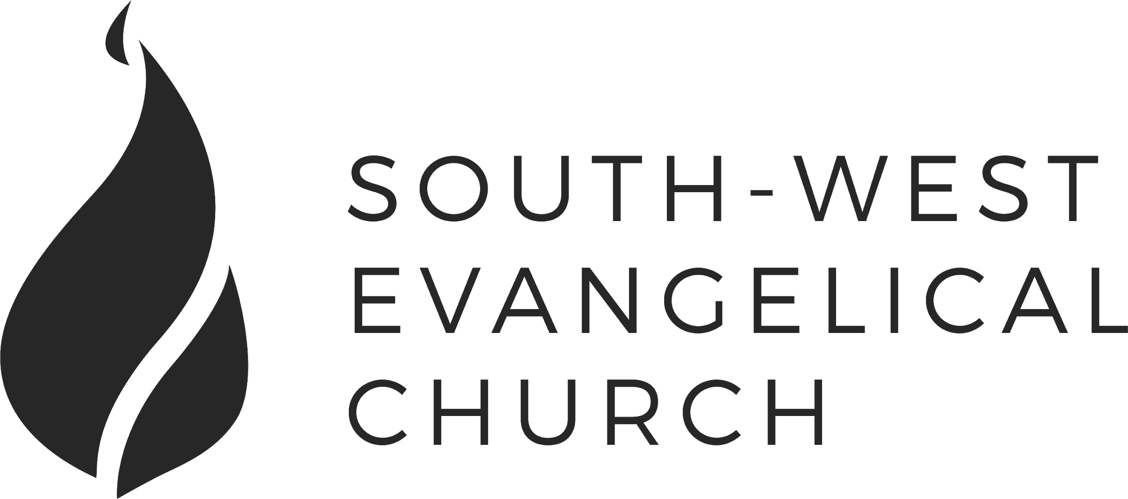

Sunday, 5 August 2018 | Bankstown | [www.swec.org.au](http://www.swec.org.au)

Pastor Dom Cheung | 0466 110 456 | dcheung@swec.org.au

What we’ll be doing during our time together

1. Worship

We’ll be worshipping God through song, prayer and by hearing His word.

Today’s confession prayer

Almighty and most merciful Father,  
You have loved us with an everlasting love,  
But we have gone our own way  
And have rejected you in thought, word, and deed.  
We are sorry for our sins  
And turn away from them  
For the sake of your Son who died for us,  
Forgive us, cleanse us and change us.  
By your Holy Spirit, enable us to live for you,  
And to please you more and more;  
Through Jesus Christ our Lord.  
Amen.

Bible reading - 1 Samuel 1:21-28

2. Community

An opportunity to get updated with what’s happening at SWEC!

3. Prayer

We’ll be praying for various needs in our church, the wider community, and the world.

4. God’s Word

Today’s sermon will be given by Peter Ko.

5. Response

An opportunity for us to respond by singing, through holy communion, and by financial giving.

6. Blessing & Sending  
Go with God’s blessing to love and serve him and the world.

|  |  |  |
| --- | --- | --- |
| **Pastors**  Peter Ko (Lead Pastor)  Stephen Fei  Dom Cheung  Karen Ko | **Elders**  Johnson Lee  Andrew Lim  Kirby Wong  Nelson Siu  board@swec.org.au | **Student Pastors**  Andrew Hayes  James Hoey  **Ministry Intern**  Lisa Truong |

The One Thing

1 Corinthians 9:1-23

Introduction

1. Rights and Wrongs
2. All Things to All People
3. The One Thing That Changes Everything
   1. Family and Friends
   2. The Work of the Lord